**MIND ANAMORPHOSIS**

**Overview & Setup Instructions v1.1**

**Michael McMahon**

**Toby Steele**

**Paul Gaffney**

**11/06/2017**

**Hack the Brain – Dublin Science Gallery**

Over 500 years ago, Paolo Uccello created The Battle of San Romano revealing a development in linear perspective which was so shocking Lorenzo Medici stole it so he could own this marvel of artistic technology

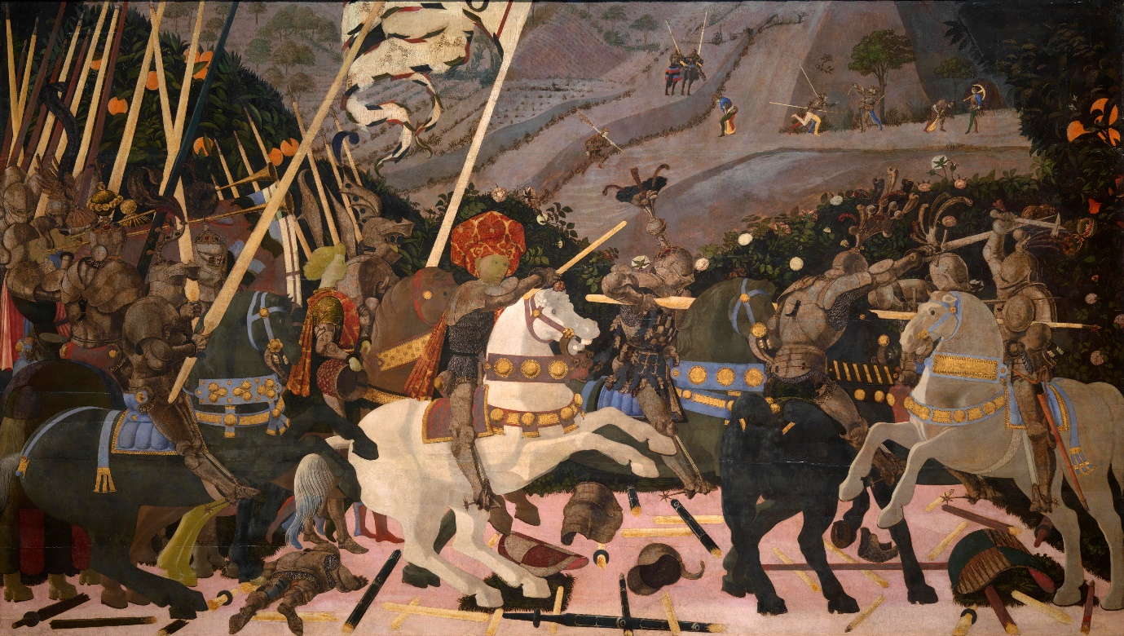

**Fig 1.** Niccolò Mauruzi da Tolentino at the Battle of San Romano (probably c.?1438–1440), egg tempera with walnut oil and linseed oil on poplar, 182 × 320 cm, National Gallery, London.

Nearly 100 years later Hans Holbein the Younger created The Ambassadors (1533), drawing on an extreme version of a technique developed by Leonardo da Vinci, added a distorted skull placed in the bottom centre in anamorphic perspective as wonderful example of memento mori.

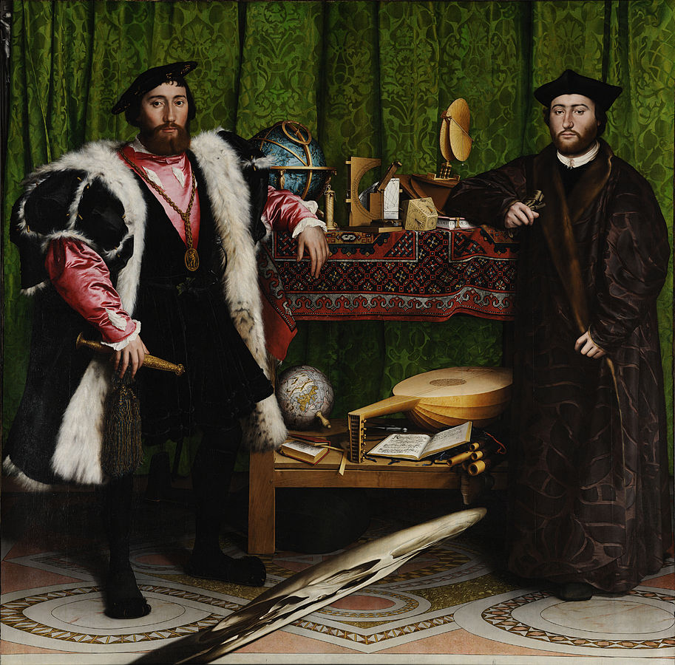

**Fig 2.** Double Portrait of Jean de Dinteville and Georges de Selve ("The Ambassadors"), 1533. Oil and tempera on oak, National Gallery, London.

Anamorphosis is a distorted projection or perspective requiring the viewer to use special devices or occupy a specific vantage point (or both) to reconstitute the image. Anamorphosis plays havoc with elements and principles; instead of reducing forms to their visible limits, it projects them outside themselves and distorts them so that when viewed for a certain point or through a device they return to normal creating a poetry of abstraction, optical illusion and a philosophy of false reality.

Salvador Dalí for example used extreme foreshortening and Anamorphism in his paintings and installations with the 3-dimensional anamorphic living-room installation with furniture that looks like the face of Mae West probably the most famous.

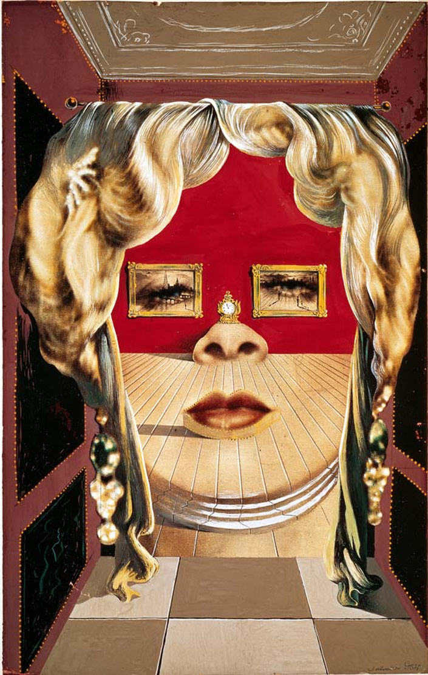

Fig 3. “Il volto di Mae West,” (original painting; 1934-35) by/© Salvador Dali. Bottom: “Gala Contemplating the Mediterranean Sea Which at 20 Meters Becomes The Portrait of Abraham Lincoln” (1976) by Dali.

Which leads to another inspiration for this work lies with the surrealist’s movement's idea of “automatic drawing” to adequately represent the unconscious mind and allow participants to step into their own painting where they might be more inclined to explore the potential personal meaning of what they find there as it responds to their thoughts – a new type of Anamorphosis - a mind Anamorphosis.

Virtual reality (VR) art allows a participant to experience disembodied presence in an immaterial, abstract space and when coupled with Brain Computer Interface it has the potential to allow a person to affect their virtual surrounding using their thoughts. We envisage the participant floating inside an immersive dreamscape VR environment, where the content of the virtual environment, visual, aural and motion can be controlled by, and responds to, the persons imagined movement.

The focus will be on utilizing two waves in the alpha and beta range in primary sensorimotor cortex indicating motor intention or motor imagery of different body parts. The Mu rhythm which in the alpha range 7.5 to 12.5 Hz and the sensorimotor rhythm (SMR) in the range of 13 to 15 Hz both of which are dominant during rest but desynchronized when an individual is planning, executing, and imagining body movements.

**Michael McMahon** I’m a Senior Program Manager in Ericsson Mediaroom with 20 years’ experience in Software Engineering within the IPTV/VOD area. I hold a BA in Sociology, Economics and Geography, H. Dip in Arts Administration and am finishing my MSc in Software Engineering with NUI Galway. My MSc Thesis is focused on the development of an open-source BCI-VR prototype to test the manipulation of 3D objects in a Virtual Reality Environments aimed at improving motor rehabilitation outcomes. I am also a filmmaker and my short drama ‘Fiddlers Cross’ won Best Screenplay at the prestigious Flickers Rhode Island International Film Festival in 2014.

**Toby Steele** I'm a software engineer and technology enthusiast who has spent more than 20 years designing and building software for organisations such as Sony, the BBC, Microsoft and Ericsson. I hold a BEng in Computer Systems Engineering, and whilst most of my professional experience has been related to the development of TV and Video technology, I have also worked on the development of hardware and software for music creation and artistic expression.

**Paul Gaffney** is a Photographer whose research is aimed at developing a meditative approach to landscape photography, and explores how the act of image making can enable and disrupt a sense of connection with one’s surroundings. Drawing on Arnold Berleant’s theory of a ‘participatory approach’ to landscape, in which the artist, environment and viewer are considered to be in continuous dialogue with each other, Gaffney’s practice proposes to communicate an experience of immersion in nature to the viewer. Gaffney's has published two photobooks’, We Make the Path by Walking, and Stray.

**Equipment**

We will be using an g.tec EEG cap, electrodes, Open BCI, Openvibe, an VR DK Oculus Rift and the Unreal Game Engine.

**Repository**

https://github.com/HackTheBrain/MindAnamorphosis

**Ethical considerations**

* No PII data will be collected
* Permission will be requested before any EEG data is recorded
* All participant data will be destroyed after the hackathon

1. Install the OpenVibe software from: <http://openvibe.inria.fr/>
2. Download the latest BCI folder from Git and save to a folder on your system <https://github.com/HackTheBrain/MindAnamorphosis/tree/master/BCI>
3. Setup your OpenBCI board as per the instructions in the OpenBCI tutorial: <http://docs.openbci.com/Tutorials/01-Cyton_Getting%20Started_Guide>
4. To connect OpenBCI to OpenVibe follow the instructions here: <http://docs.openbci.com/3rd%20Party%20Software/03-OpenViBE>
5. Make sure you read the additional Driver setup information here: <http://openvibe.inria.fr/drivers-openbci/>
6. Setup the electrodes on your headset. We use the positions highlighted below in Purple

Electrodes were positioned at: FC3, Fz, FC4, C3, Cz, C4, P3, Pz, P4, PO7, Oz, PO8

The Ground Electrode was positioned at: Fpz

The BIAS Electrode was positioned on the Right Ear Lobe

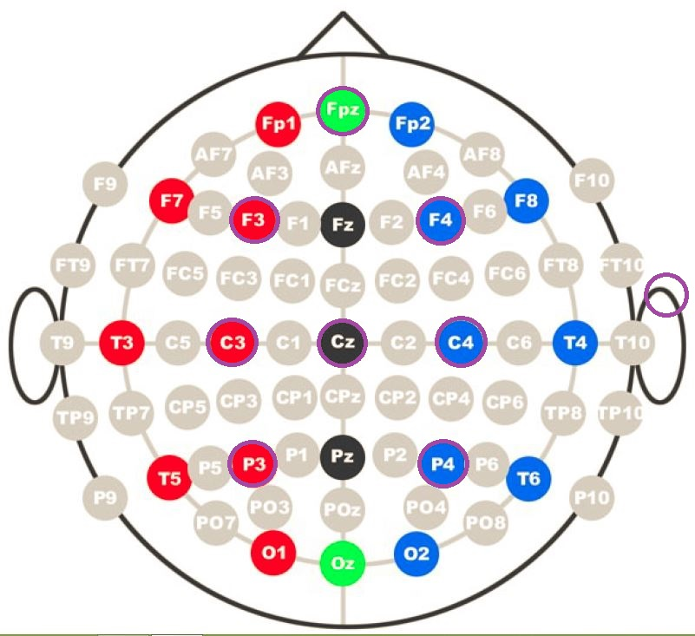

1. We connected the Electrodes to the following inputs on out OpenBCI board.

|  |  |  |  |
| --- | --- | --- | --- |
| Electrode | g.tec Ch Number | Colour | BCI Input |
| **FC3** | **9** | **Purple** | **8** |
| **FC4** | **10** | **Blue** | **7** |
| **C3** | **11** | **Green** | **6** |
| **Cz** | **2** | **Yellow** | **5** |
| **C4** | **12** | **Orange** | **4** |
| **P3** | **3** | **Red** | **3** |
| **P4** | **5** | **Brown** | **2** |
| Ref |  | Grey | SRB |
| Gnd |  | White | AGND6 |

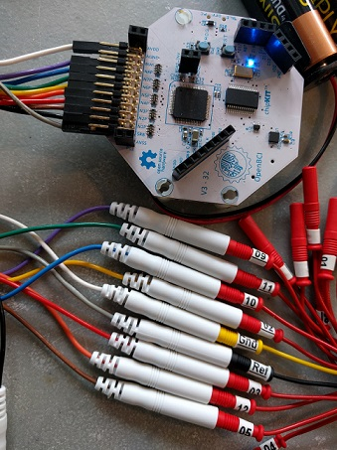

1. Follow the instructions here to setup the Channel Acquisition for your specific headset electrodes <http://openvibe.inria.fr/channel-selection-in-acquisition-server/>
2. This set of scenarios implements the Graz BCI, based on motor imagery of the hands. It computes the spatial filters that efficiently discriminate the signal using CSP, for significantly better performances. The scenario is based on the example scenario provided with OpenVibe which you will find it in [Your Location]:/openvibe/share/openvibe/scenarios/bci-examples/motor-imagery-CSP

**mi-csp-0-signal-monitoring.xml:** This scenario should be always used prior to anything and in background to check the signal quality of the acquisition device. Once you are sure that the EEG acquisition runs correctly, you can go on to the next step.

**mi-csp-1-acquisition.xml:** First step is to acquire some data in order to train the classifier that will discriminate Right and Left hand movements. The training session can be configured in the LUA stimulator (number of trials, timings, etc.).

**mi-csp-2-train-csp.xml: This** scenario computes Common Spatial Pattern to produce a spatial filter that maximizes the difference between the signal of the two classes. Use a previously acquired file to perform the training.

**mi-csp-3-classifier-trainer.xml:** This scenario trains a LDA classifier based on the previous acquisition session. Note that the signal processing pipeline may be tuned according to the type of data acquired. For example, the Reference Channel may not be needed.

**mi-csp-4-online.xml:** This scenario adds real-time feedback to the visualization, using the trained LDA classifier. Again, you may have to tune the signal processing pipeline.

**mi-csp-5-replay.xml:** This scenario is based on the online one, but the input signal is coming from a file rather than acquisition server. In this version classifier performance tools are used to display the confusion matrix of the classifier and its global performance during the session.

1. Once the training and calibration is completed download to Anamorph folder from GitHub here: <https://github.com/HackTheBrain/MindAnamorphosis/tree/master/Anamorph>
2. Load and run the scenario BciControllerInput-v2.xml in OpenVibe from the BCI folder which will collect live EEG data and send that data to the unreal engine via VRPN. VRPN (Virtual-Reality Peripheral Network) is a device-independent and network-transparent system for accessing virtual reality peripherals in VR applications. You can find more information on configuration of VRPN with OpenVibe here: <http://openvibe.inria.fr/vrpn-tutorial-sending-data-from-openvibe-to-an-external-application/>
3. Launch the Unreal Engine and load the project file: \Anamorph\Anamorph.uproject

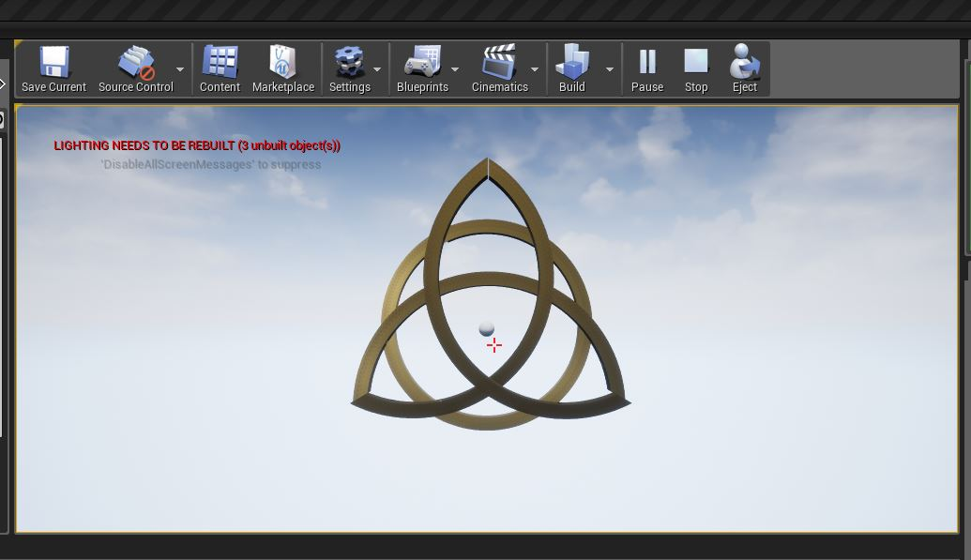

1. Play the application as “VR Preview”

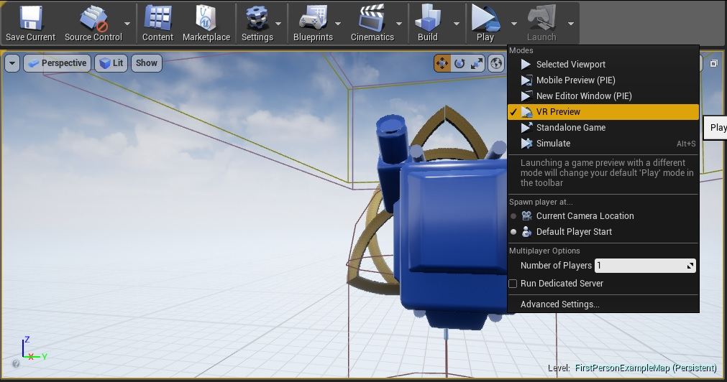

1. Start controlling the anamorphic VR object using brain waves

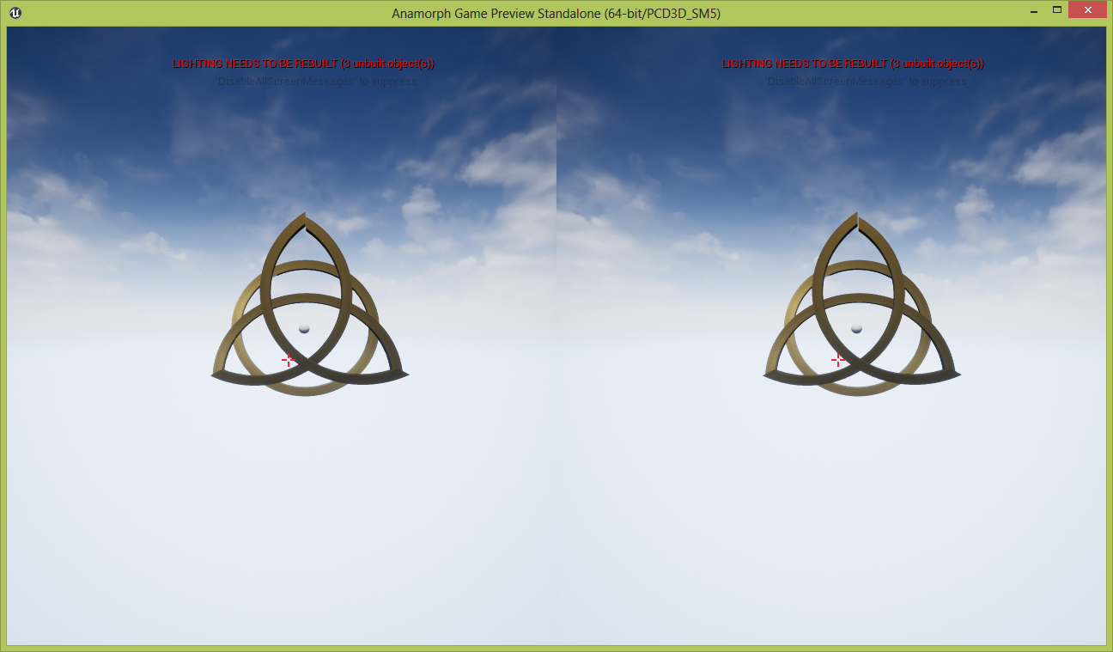

**ISSUES ENCOUNTERED**

**FUTURE WORK**